ROSÉ 2022

Indication Géographique Protégée – Terres du Midi

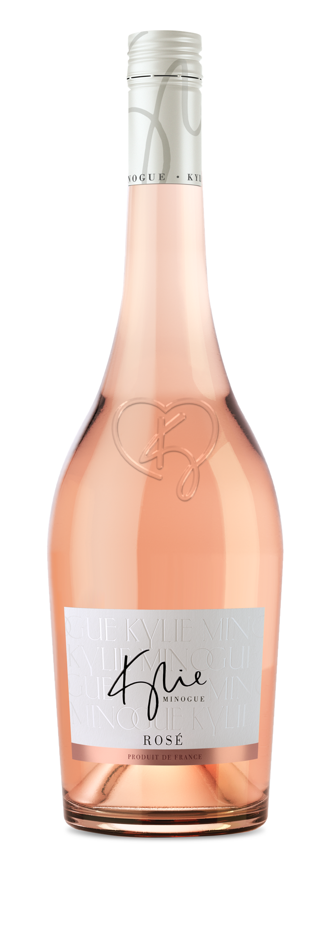

Blend: 80% Grenache + 20% Cinsault

Sugar: 3gl total

ABV: 11%

Viticulture:
- The grapes are sourced from the sun-drenched southern French coast.
- Cooling sea breezes help to keep grapes in optimum health and allow the development of expressive aromas and bright acidity.
- Conventional guyot and goblet vine training.

Vinification:
- Grapes are night harvested to protect from oxidation and preserve aromas.
- After destemming, the grapes are gently pressed and then processed through static racking.
- Fermentation is maintained at a cool temperature to preserve freshness.
- Matured in stainless steel tanks for 3 months on its fine lees to add texture and complexity.
Tasting note:
- Beautifully pale pink shade with delicate, alluring aromas of fresh summer berries and white blossom. Refined and refreshing on the palate with a fruity, crisp finish.

Suitable for vegans.
info@benchmarkdrinks.com

